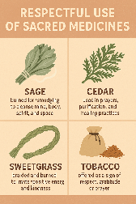
Respectful use of Sacred Medicines
Sacred medicines—such as sage, cedar, sweetgrass, and tobacco—are used respectfully in many Indigenous ceremonies and traditions across Turtle Island (North America), but their use and meaning can vary between Nations.

Common respectful uses:
- Sage: Burned for smudging to cleanse the mind, body, spirit, and space.
- Sweetgrass: Braided and burned to invite positive energy and kindness.
- Cedar: Used in prayers, purification, and healing practices.
- Tobacco: Offered as a sign of respect, gratitude, or prayer—placed on the earth or given to an Elder or Knowledge Keeper when asking for teachings.

Variation among Nations:
- Protocol and teachings differ: For example, some Nations may use only tobacco in offerings, while others combine medicines in specific ways.
- Language and cultural context shape meaning: One Nation may see sweetgrass as symbolic of the braiding of mind, body, and spirit, while another may associate it with the Sacred Feminine.
- Access and ecological practices matter: Some communities have protocols for harvesting medicines, often involving prayer and a tobacco offering to the plant.
Respect is shown by:
- Learning directly from Knowledge Keepers or Elders.
- Not appropriating or commercializing medicine use.
- Understanding that ceremony is lived, not replicated—context and guidance matter deeply.

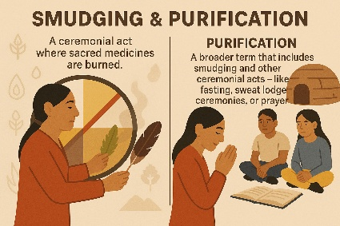
Smudging and Purification
Smudging and purification are spiritual and cultural practices rooted in many Indigenous traditions. They are ways to cleanse, center, and reconnect with self, community, and the land.

Smudging
- What it is: A ceremonial act where sacred medicines (like sage, cedar, or sweetgrass) are burned.
- Purpose: The smoke is used to cleanse a person, object, or space of negative energy, thoughts, or emotions.
- How it's done: The smoke is fanned over the body, often with a feather, and prayers may be said. People often smudge their head, eyes, mouth, heart, and feet to bring clarity and good intentions to their thoughts, words, and actions.

Purification
- What it is: A broader term that includes smudging but can also involve other ceremonial acts—like fasting, sweat lodge ceremonies, water bathing, or prayer.
- Purpose: To prepare oneself spiritually, mentally, emotionally, or physically for important events, decisions, or healing.
- Context matters: Purification practices vary greatly depending on Nation, family tradition, and teaching. It’s always best learned with the guidance of an Elder or Knowledge Keeper.

